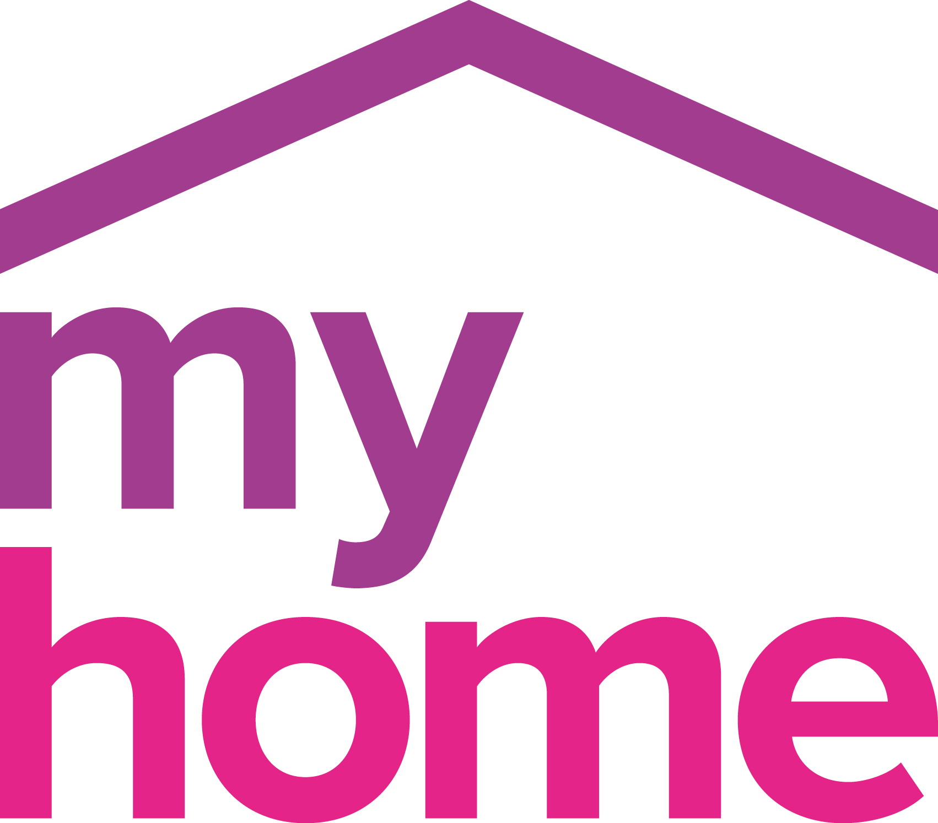
TERMS & CONDITIONS handyman

- DEFINITIONS
In these Terms and Conditions:
" Housework" describes any Myhome Handyman service.
" Housework Small Job" means a Housework charged at hourly rate and a minimum charge of £65.
" Housework Big Jobs" means a Housework charged at pre-agreed cost.
"Booking" means the use of one of our services on one particular occasion.

- APPLICATIONS
Myhome Handyman intend to rely on the terms included in this document. If you require any changes, please make sure that they are put in writing so that we can avoid any problems surrounding what you and we expect.

- PRICING & PAYMENT TERMS

3a. Price Changes/VAT
All prices are subject to change and exclusive of VAT.

3b. Payment method
Housework Small Jobs and Housework Big Jobs customers may pay by Cheque, Cash, Credit card/Debit card OF BACS.

3c. Minimum charges
Housework Small Jobs per hour - £65.00
Housework Big Jobs per day- £300.00

3d. Payment timing
Payment must be made to Myhome Handyman on of the day of the service.

- CANCELLATION /NON DELIVERY OF SERVICES
4a. Customer Cancellation/Non Attendance
Housework Small Jobs Cancellation. A 100% charge is applied where less than 1 business day notice is given to cancel, and 50% where between 1 and 2 business days’ notice is given.
Housework Big Jobs Cancellation. For cancellations within 1 business day, 100% fee will be charged. For cancellations between 1 and 2 business days, 50% will be charged. If Myhome Handyman is unable to gain access to the property, as a result of customer failure to make reasonable arrangements for access, Myhome Handyman will charge the full cancellation fee.

4b. Myhome Handyman Cancellation/Non Attendance
Myhome Handyman may be responsible for losses you suffer as a result of us breaking this agreement if the losses are a foreseeable consequence. Losses are foreseeable where they could be contemplated by you and us at the time the agreement was made. We may not be responsible for indirect losses which happen and which were not foreseeable by you and us.
In such circumstances Myhome Handyman will use its best endeavors to arrange an alternative time suitable to both parties for the performance of its services. Where Myhome Handyman fails to carry out an agreed service due to circumstances within our control, our liability shall be limited to providing the agreed service at no additional charge at a mutually convenient alternative time and in no event shall Myhome Handyman be liable for any other losses including loss of profit or consequential loss.

4c. Consumer Protection (Distance Selling) Regulations
Where a booking constitutes a distance contract pursuant to the Consumer Contracts (Distance Selling) Regulations 2013, you will have the right to cancel the contract within 7 days of the formation of the contract, but you will not have the right to cancel the contract where the performance of the Housework has commenced.

- WORKING CONDITIONS
5a. Health & Safety
In order to protect the handyman operative, they are instructed to carry out an assessment prior to commencing any job and not to enter an environment they consider to be unsafe, dangerous to health, or inoperable for any reason, but are instructed to withdraw from the premises and to report the problem to management for further investigation. In this event the customer will be charged 100% of the cost of the booking, should it be the negligence of the customer. If there has been a charge and when the Housework is rescheduled (after the environment has been rendered safe), the customer will be charged a fee equivalent to 50% of the cost of the original Booking.

5b. Equal Opportunities
Myhome Handyman is an Equal Opportunities Employer. We recruit our home cleaners on the basis of their ability to do the job and aim to ensure that all home cleaners are treated equally regardless of ethnic origin, religion, sex, age, marital status, nationality, sexual orientation or disability.

- USE OF CUSTOMERS' EQUIPMENT
Our staff are strictly instructed not to use any of your personal equipment while in your home. You agree to permit staff members to use the telephone ONLY to call the Customer Service team on a local number if necessary.

- LIABILITY
7a. Key holding
Myhome Handyman undertakes to provide absolute security for your keys at all times. In the unlikely event of any keys being lost by Myhome Handyman, we will make appropriate arrangements as soon as reasonably possible. Myhome Handyman shall not be liable for any loss or damage as a result of an unavoidable delay caused by you.

7b. Liability for death or personal injury
Nothing in this contract shall limit or exclude Myhome Handyman’s liability for death or personal injury caused by negligence.

- COMPLAINTS
In the event of you being dissatisfied with the service you have received from Myhome Handyman, you should contact the Myhome Handyman Customer Service team within 4 days. Myhome Handyman will endeavor to ensure that all your concerns and complaints are resolved quickly and amicably with our Customer Service team.

- COMPENSATION
9a. Housework
Damage to/ Loss of Property. In the event of damage or loss as a result of negligence, the liability of Myhome Handyman shall be limited (at Myhome Handyman discretion) to repair or the replacement cost of the item, as soon as reasonably possible taking into account its age and condition. Myhome Handyman shall not in any event be liable for any loss of profit or consequential loss unless caused as a result of our negligence.

9b. Claiming Compensation
Any claim for compensation must be notified to the Customer Service team as soon as possible and in any event within 4 days of the damage occurring.

- USE OF CUSTOMER INFORMATION
The information you give will be held and used by Myhome Handyman to perform the business for which we are registered. This may include sending you details of Myhome Handyman offers and services that may be of interest to you.

Myhome Handyman Ltd t/a Myhome Handyman:
Customer Services: 0208 802 4040
www.myhome.co.uk

